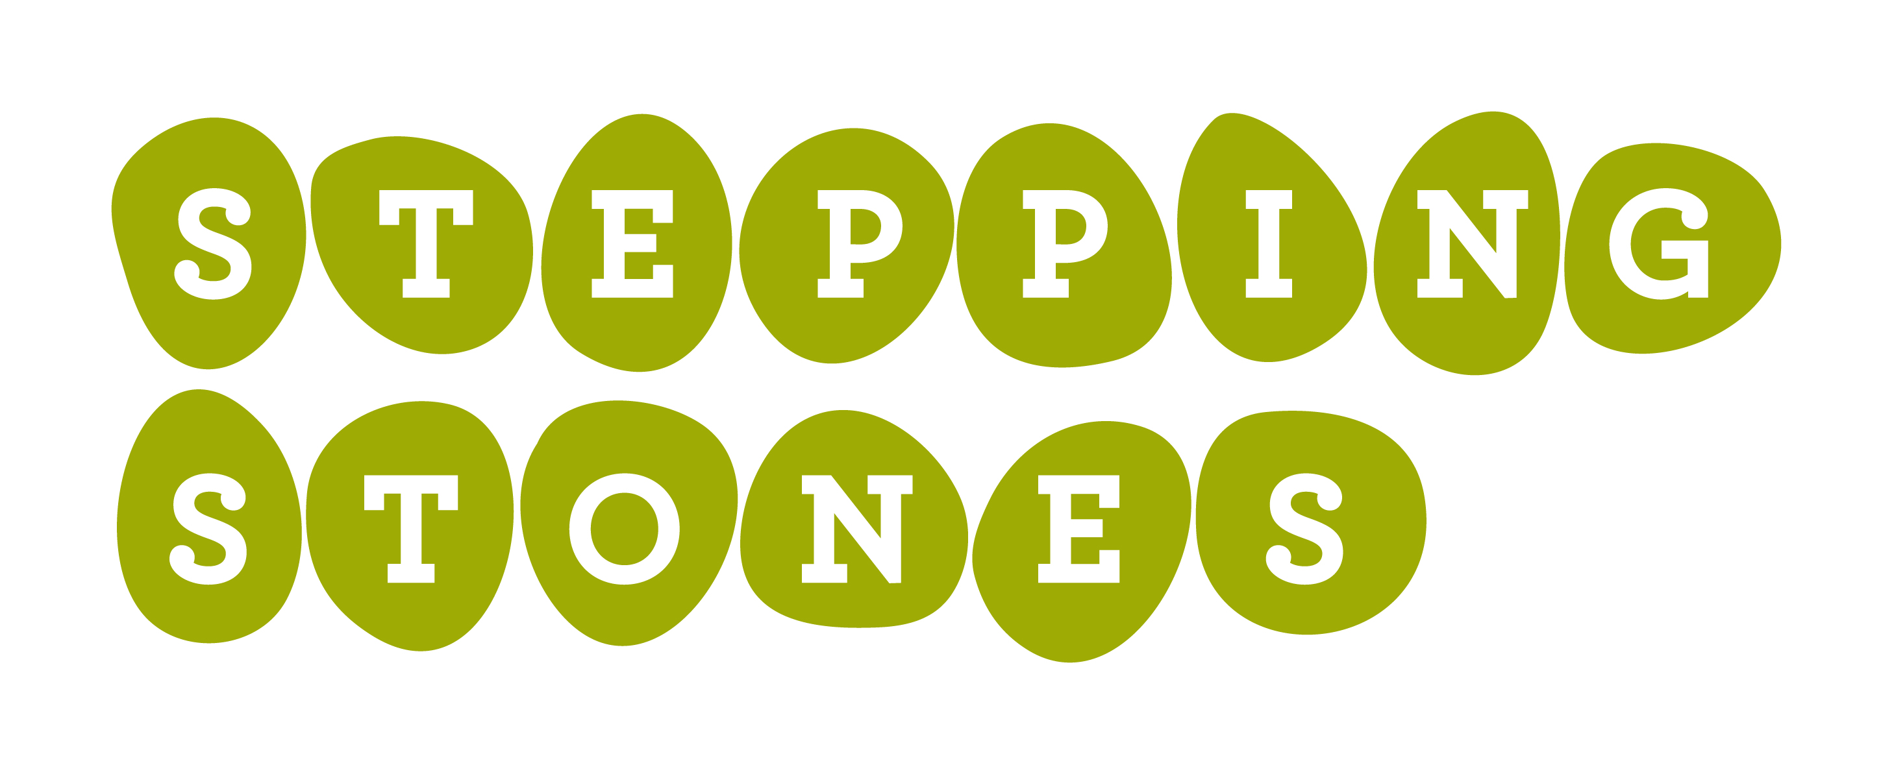
WEEKEND RECREATION PROGRAMS & DEADLINES
Registration for Fall, Winter and Spring recreation programs through 2022 is now open! Listed below you will find dates for the upcoming Respite and Saturday Club programs as well as the three-week registration deadline.
Stepping Stones requires all registration paperwork to be submitted by this registration deadline to ensure adequate time for processing each application. If we do not receive a registration by the listed deadline, the participant will be unable to attend that program session.
Please feel free to contact us with any questions at (513) 831-4660.

Saturday Kids Club & Saturday Young Adults Clubs*

SESSION DATE REGISTRATION DEADLINE
September 11, 2021 August 20, 2021
September 18, 2021 August 27, 2021
September 25, 2021 September 3, 2021
October 2, 2021 September 10, 2021
October 9, 2021 September 17, 2021
October 16, 2021 September 25, 2021
October 23, 2021 October 1, 2021
November 6, 2021 October 15, 2021
November 13, 2021 October 22, 2021
November 20, 2021 October 29, 2021
December 4, 2021 November 12, 2021
December 11, 2021 November 19, 2021

2022 Dates
January 15, 2022 December 23, 2021
January 29, 2022 January 7, 2022
February 12, 2022 January 21, 2022
February 26, 2022 February 4, 2022
March 12, 2022 February 18, 2022
March 26, 2022 March 4, 2022
April 9, 2022 March 18, 2022
April 23, 2022 April 1, 2022
September 17, 2022 August 26, 2022
October 1, 2022 September 9, 2022
October 15, 2022 September 23, 2022
October 29, 2022 October 7, 2022
November 12, 2022 October 21, 2022
December 12, 2022 November 18, 2022

WEEKEND OVERNIGHT RESPITES* (ALLYN CAMPUS)

SESSION DATE REGISTRATION DEADLINE
September 17 – 19, 2021 August 27, 2021
October 1 – 3, 2021 September 10, 2021
October 15 – 17, 2021 September 24, 2021
October 29 – 31, 2021 October 8 – 10, 2021
November 12 – 14, 2021 October 22 – 25, 2022
December 10 – 12, 2021 November 19, 2022

2022 Dates
January 7 – 9, 2022 December 17, 2021
January 21 – 23, 2022 ` December 30, 2021
February 4 – 6, 2022 January 14, 2022
February 18 – 20, 2022 January 28, 2022
March 4 – 6, 2022 February 11, 2022
March 18 – 20, 2022 February 25, 2022
April 1 – 3, 2022 March 11, 2022
April 29 – May 1, 2022 April 8, 2022
September 9 – 11, 2022 August 19, 2022
September 23 – 25, 2022 September 2, 2022
October 7 – 9, 2022 September 16, 2022
October 21 – 23, 2022 September 30, 2022
November 4 – 6, 2022 October 14, 2022
November 18 – 20, 2022 October 28, 2022
December 2 – 4, 2022 November 11, 2022
December 16 – 18, 2022 November 23, 2022

PLEASE NOTE:
Maintaining the health and safety of our program community remains Stepping Stones’ top priority. As we continue navigating COVID-19, please note that program dates are subject to cancellation if directed by state and local officials.

To learn more about any of the programs listed above, please visit our website at:
www.SteppingStonesOhio.org

